- \Operation\Trimming station A\Trimming station A
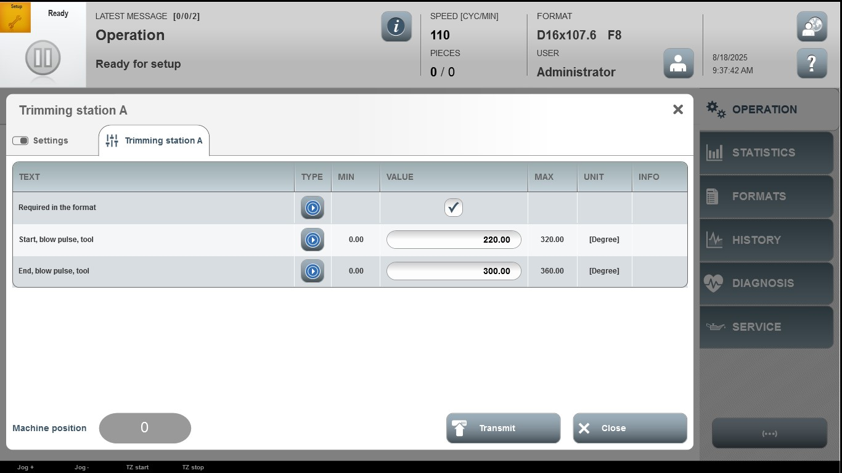

Acceptance criterion | Limits | Pass / Fail: Dev-No. | Date | Initials
Screen matches screenshot | N / A
Start, blow pulse, tool | 0.00 … 320.00
End, blow pulse, tool | 0.00…360.00

